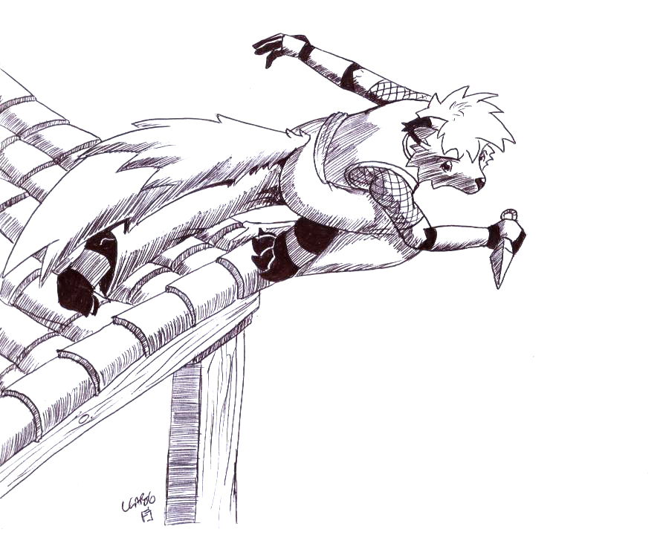

Fox Anthro Template

Disadvantages:
Hallucinations (Distorted sense of friend/foe)
Stigmata (Mental Incapacitation [-2 Will])
Secret (TBD)
Hunted
Valuable

Duties: Shinobi guild
Restriction: Cannot wear armor

Kiiro Hirameki AC – 22 = 10 + 8 + 2 + 2 HP (3d10) = 29 BAB = 3

Strength – 8 Saves: Reflex – 10 = 1 + 8 + 1
Dexterity – 18 + 8 Fortitude – 5 = 2 + 2 + 1
Constitution – 10 + 4 Will – 6 = 3 + 2 + 1
Intelligence – 15
Wisdom – 14
Charisma – 8

Abilities

-Adept (Stealth, Acrobatics, Martial Arts, Perception)
-Awareness
-Berserker – +4 Dex, +4 Manifester level/Dimension abilities – Corrupted/Only triggers after a hallucination
-Legionary
-Fast Learner/Skills
-Innate Enchantment – Dimension Hop, +2 Dex, Skill Mastery/Dex (+2 on Dex-based skills), Sidestep (+1 to all saves)
-Immunity – Dimension Hop manifester level is equal to character level
-Finesse – Dex to Hit
-Finesse – Int to Damage
-Augment Attack – 1d6 Sneak Attack

Kunai - +11 to hit Damage – 1d8 + 2

Longsword - +11 to hit Damage – 1d8 + 2

Skills Ranks Attribute Misc

Acrobatics 16 6 8 2
Computer Use 5 3 2 0
Martial Arts (Dex) 16 6 8 2
Perception 12 6 2 4
Stealth 16 6 8 2
Thievery 13 3 8 2

Martial Arts (Dex) – Yondaime

Basic Abilities:
Defenses 2
Power 2

Advanced/Master Techniques:
Whirlwind Attack
Versatility
Instant Stand

Occult Techniques:
Inner Strength

